***Business Reason***

Subway CSA should not have black pages, it looks unprofessional.

***Task Requirements***

1. Quote # A149011, Account 853-3528075

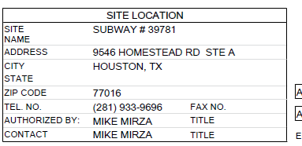

1. Fixed in dev, see quote A147510

***Build Plan***

Resolved by previous CSA projects. For TCs 14, the spaces were removed between paragraphs.

***Admin Guide Changes***

None.

***User Guide Changes***

None.